**Field at Center of Current Loop**

|  |  |
| --- | --- |
| http://hyperphysics.phy-astr.gsu.edu/hbase/magnetic/imgmag/loopc.gif | The form of the [magnetic field](http://hyperphysics.phy-astr.gsu.edu/hbase/magnetic/magfie.html#c1) from a current element in the [Biot-Savart law](http://hyperphysics.phy-astr.gsu.edu/hbase/magnetic/biosav.html#c1) becomes  http://hyperphysics.phy-astr.gsu.edu/hbase/magnetic/imgmag/loopc2.gif  which in this case simplifies greatly because the angle =90 ° for all points along the path and the distance to the field point is constant. The integral becomes  http://hyperphysics.phy-astr.gsu.edu/hbase/magnetic/imgmag/loopc3.gif  http://hyperphysics.phy-astr.gsu.edu/hbase/magnetic/imgmag/mu0.gif |

as B = µ0 H;

The magnetic field strength in the center of a loop is

*H*z =

**Field on Axis of Current Loop**

|  |  |
| --- | --- |
| http://hyperphysics.phy-astr.gsu.edu/hbase/magnetic/imgmag/loopa.gif | The application of the [Biot-Savart law](http://hyperphysics.phy-astr.gsu.edu/hbase/magnetic/biosav.html#c1) on the centerline of a [current loop](http://hyperphysics.phy-astr.gsu.edu/hbase/magnetic/curloo.html#c1) involves integrating the z-component.  http://hyperphysics.phy-astr.gsu.edu/hbase/magnetic/imgmag/loopa2.gif  The symmetry is such that all the terms in this element are constant except the distance element dL , which when integrated just gives the circumference of the circle. The magnetic field is then  http://hyperphysics.phy-astr.gsu.edu/hbase/magnetic/imgmag/loopa3.gif |

where R – radius of the loop and z – distance from the center of the loop on z axis

If z >> R, (z2 +R2) --> z2, then, *B*z = =

if z = 0, then *B*z = =

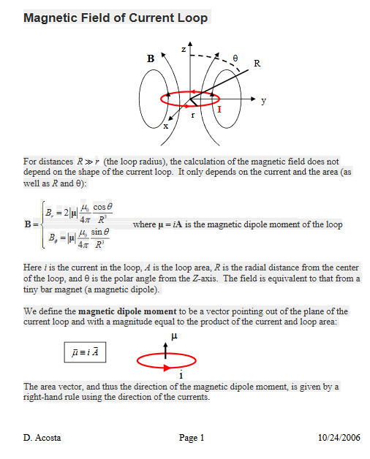

PHY2061 Enriched Physics 2 Lecture Notes

Magnetic Dipoles

Converting from polar (r, θ) to cartesian (z, y) coordinate system:

**On z axis when z >> R**

In a point (r, 0) / (z, 0) vectors $\hat{r}$ = $\hat{z}$, and $\hat{θ}$ = $\hat{y}$

Since sin(0) = 0, *Bθ* = 0, therefore

*B = Br = Bz = 2IA* = *IR2* =

where ***A=πR2***; ***R*** is the radius of the loop.

**In-plane when y >> R**

In a point (r, π/2) / (0, y) vectors $\hat{r}$ = $\hat{y}$, and $\hat{θ}$ = - $\hat{z}$

Since cos(π/2) = 0, *Br* = 0, therefore

*B = Bϴ = - Bz = - IA* = - *IR2* = -

**Arbitrary point in space**

$\vec{B}$*=Br* ***r*** *+ Bϴ* ***ϴ***

where ***r***  and ***ϴ*** are unit vectors in polar coordinate system